The Garonne presentation

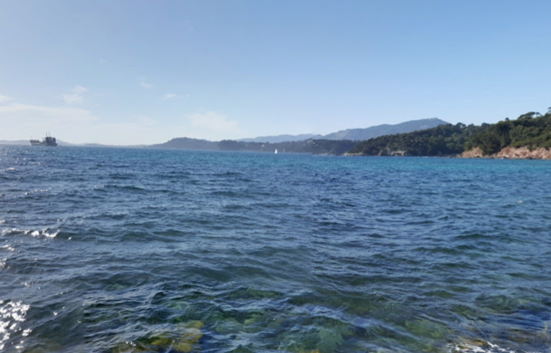
Groupe 1: location

Le Pradet is in the south of France, on the French Riviera in the Var, near Toulon. La Garonne is a beach of Le Pradet and its location is 43 N; 6. E.
We can see that, through ages, the territory has changed. Lots of houses have appeared and fields have been urbanised.
From the beach, we can see hills such as: Le Faron and the fort of Six-fours and cities such as : La Garde, Toulon, La Seyne, We can also see the Peninsula of St Mandrier

Groupe 2 ; The Mediterranean characteristics :

In autumn, the air is warm but getting cooler and wet → rain, thunderstorms.
In winter, the air is cool and dry.
The average temperature is above 5°C.
Temperature can often go down but never below -10°C
In spring, the air is warm but getting hotter and wet → rain, thunderstorms.
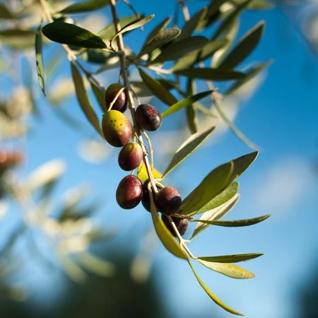
In summer, the air is hot and dry → drought.
average temperature above 22°C near the sea, temperatures can often exceed 30°C in the countryside and usually go up to 40th °C over the sea
Specific trees : olive trees
The mountains help to keep the warmth in the area
7.5 million inhabitants are living in the Mediterranean climate around the world and there are 10 217 in the Pradet.

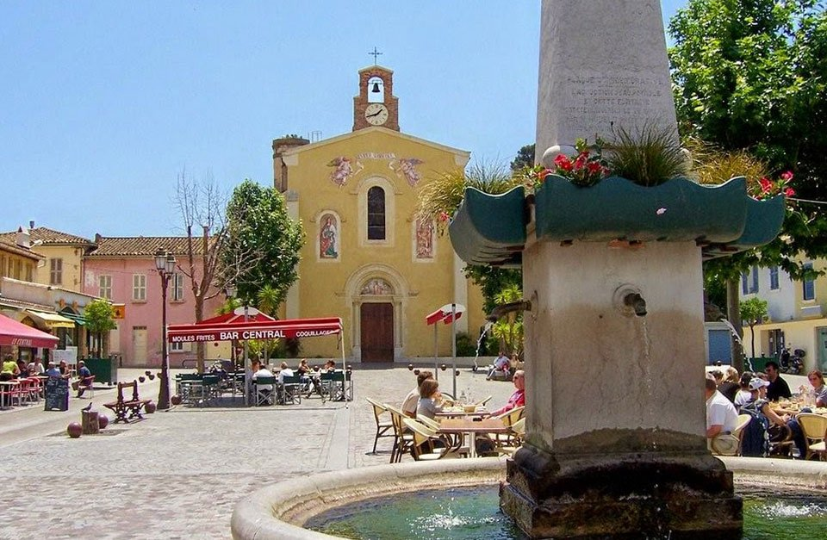
Groupe 3 : Presentation of le Pradet

Le Pradet is located in the south-east of France. It joined the charter of the national park of Port-cros, which was created in 1963.
At the beginning, le Pradet was a neighbourhood of la Garde but on the 18th of June 1894 it became an independent town.
The name of le Pradet means “Lou Pitchoun Prat” in Provencal, so little field in English.
Le Pradet contains 2 principal natural places : the massif of “La Colle Noire” and the “natural Park” which join la Garde and le Pradet. The name of la Colle Noire comes from its industrial past and means “Black hill” .

GROUPE 4 : DIVING IN LE PRADET
Esteban Stricker, Paganelli Elodie et Meunier Lise
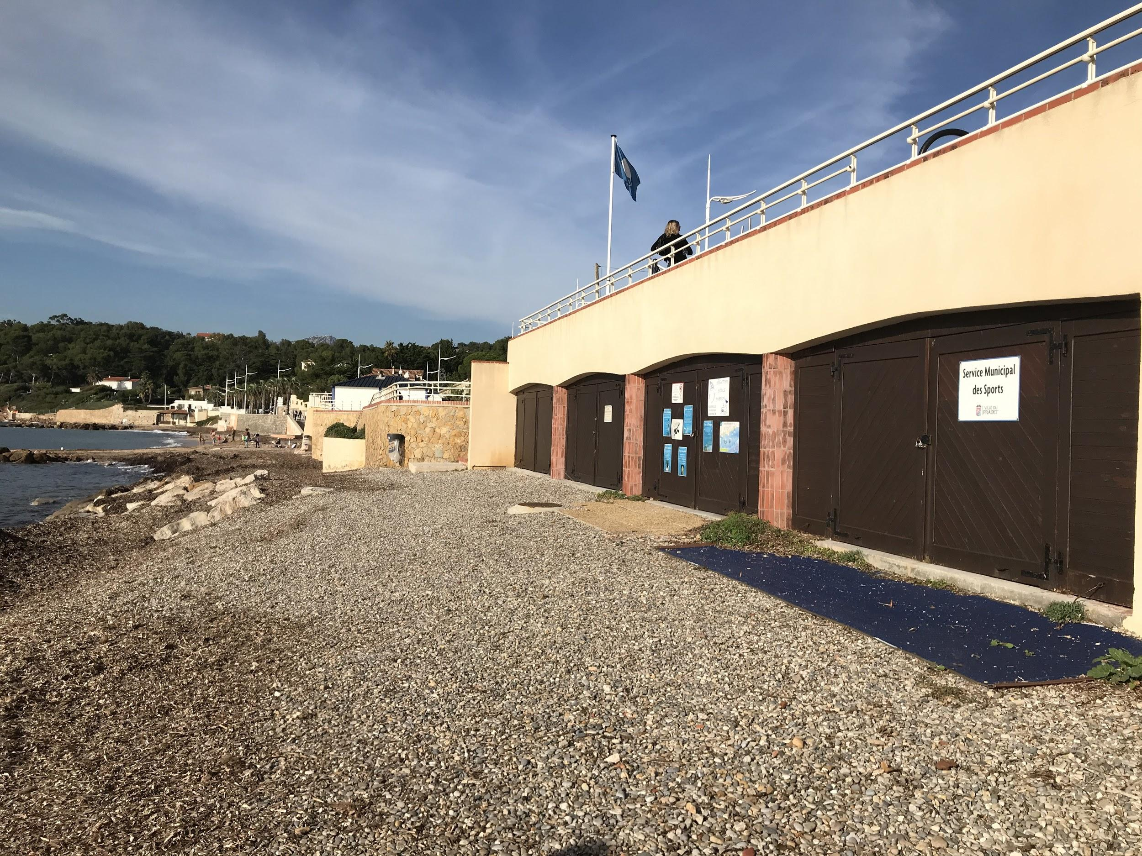
The instructions to dive :
Do not beat your legs violently to avoid making the fish flee. Spit in the mask to prevent fogging. Blow through the nose to remove the water in the mask and unzip. Watch out for jellyfish. Rinse all equipment before changing.
The equipment :
To dive, we needed : a wetsuit, goggles, fins, a snorkel, fins, à snorkel and the instructor has a buoy.
The preparation to dive :
Before going in the water, we had to : put our wetsuit on, take the goggles and fins, go on the beach, spit in the mask and rinse it and finally sit in the water and put the fins on.
The interviews
In general, this morning at Le Pradet was a success. Most of the students liked it. Before going on a dive, some people got cold, sore foot because we were walking on rocks, were afraid of jellyfish, students were cold because of wet and cool wetsuits, some of them had broken fins, a few were hungry, we were excited to go in the water.

Groupe 5 : Observation of the fauna and flora

The depth of Garonne beach is about 3 to 5 meters and the area is about 150 meters.
We saw : octopus, jellyfishes, morays, starfishes, sea cucumbers, sea urchins, salemas and peacocks.
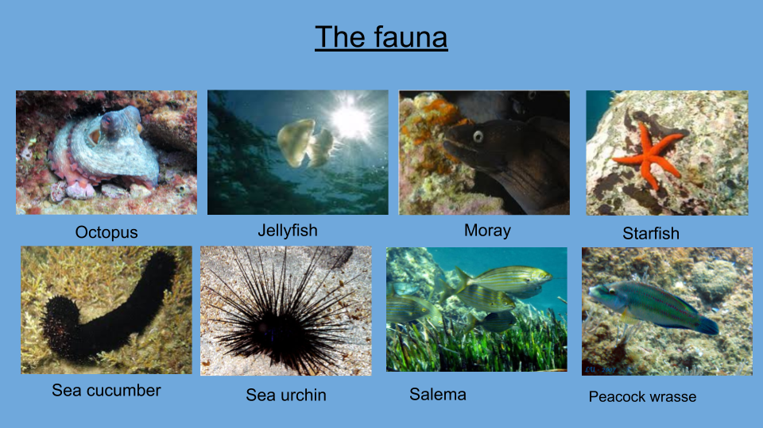
We also could see different alga : posidonia, peacock alga, cytoseira, ball codium.
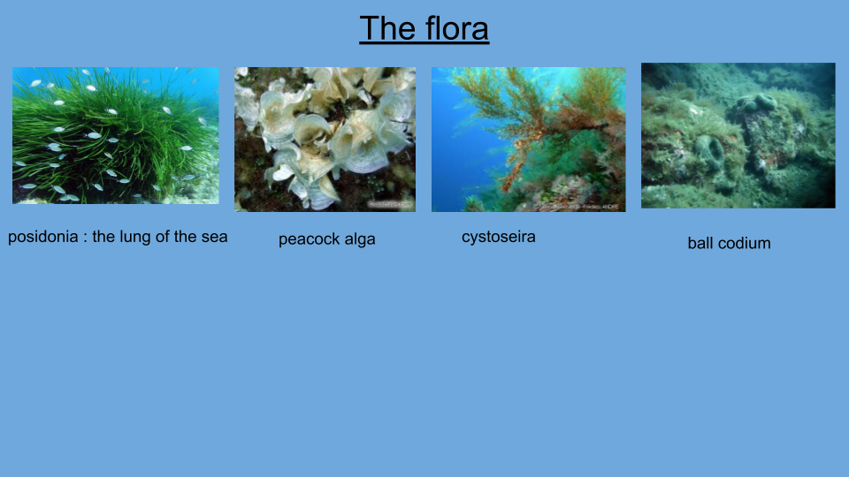

Groupe 6 : impressions

Everybody liked scuba diving. They said it was great to discover new things like fishes, starfish, octopus…
The trash part was pleasant too because it was great to “help the Earth”
The class had difficulties with the fins because it was hard to swim with .
Breathing with a snorkel was difficult as well.
Most of our class thought the water temperature was too cold to fully enjoy this experience.
Plus there were jellyfishes in the sea which might have been dangerous.
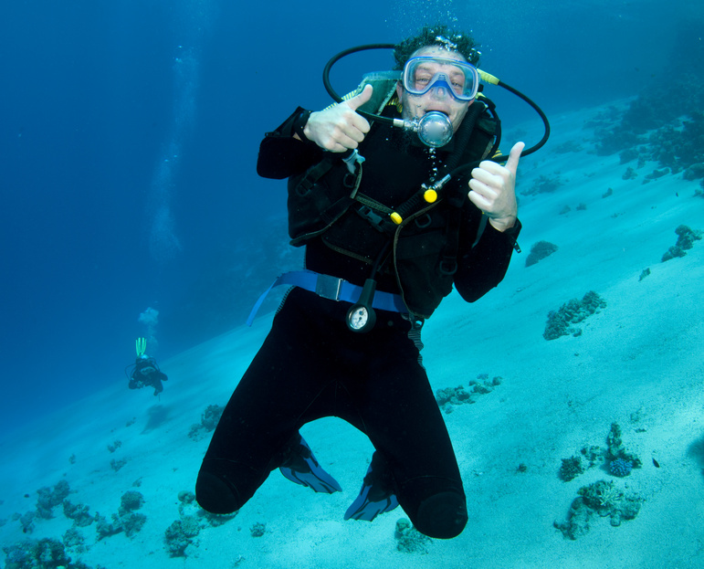

groupe 7 : Waste Collection

For us, we picked up waste on the beach. On Garonne beach we found much waste and that’s very sad for the earth. First we put on gloves and we took garbage bags. Afterwards we picked up waste : we found a lot of cigarette stubs, plastic bottles, iron pieces because people did installation on the beach, cans in the sand and also on the beach and finally we picked up tissues everywhere in the sand.
In our vision of things, we think that was great to” help the earth” and also to discover another part of the beach. Take care of our world !
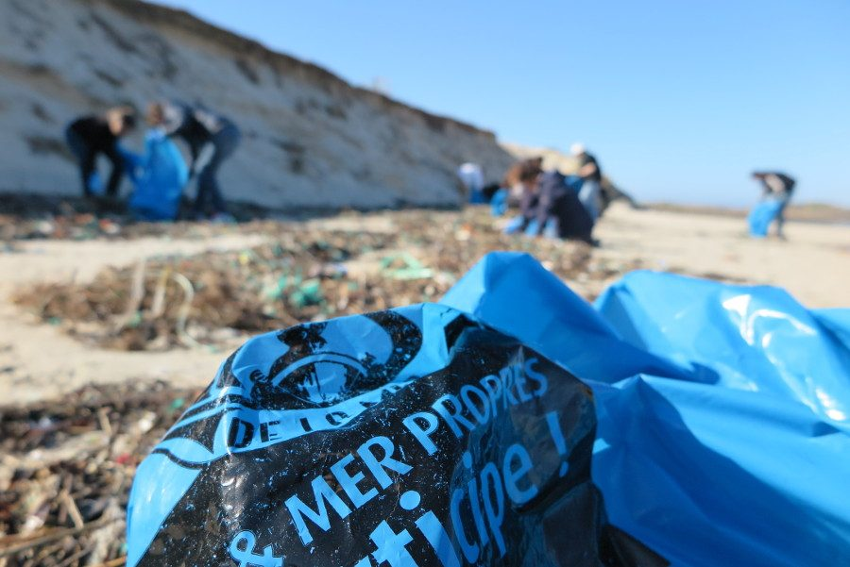

groupe 8 : zero waste picnic
It seemed hard to do it at first but when you think about it there are so many solutions to replace plastic or individually wrapped items.
Here are some ideas to make a zero waste lunchbox :
-instead of putting your sandwich into aluminium paper, you can put it in a reusable plastic box. Then you can put your salad in a mason jar. You can use a washable cloth napkin to pack your lunch for example. With the lunch you can take reusable cutlery instead of plastic cutlery. To drink we can use a bamboo straw or a flask.
Unfortunately, it’s not always possible not to have any waste because we live in a world where almost everything is wrapped. So, it’s important to recycle what we can.
For example when we picked up the waste on the beach we used garbage bags.

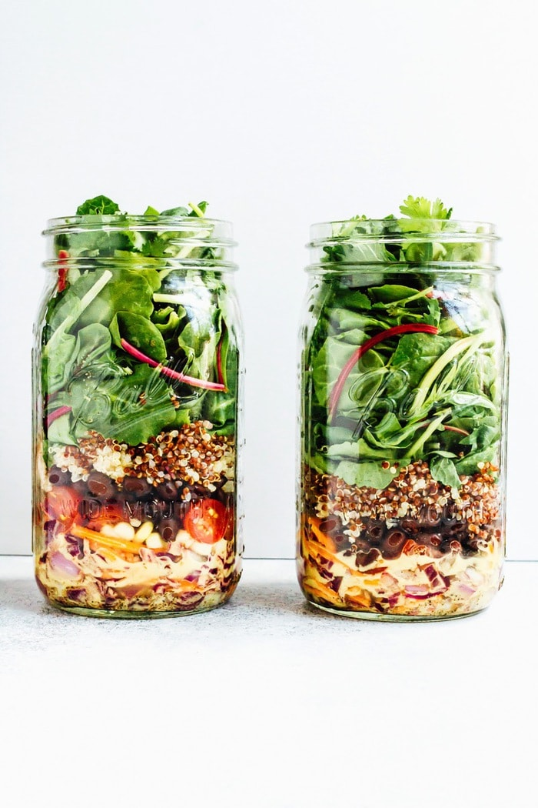

Vocabulary :
cool = frais
wet = mouillé
wetlands = zones humides
copper mine = mine de cuivre
seaside resort = station balnéaire
to spit = cracher
surefoot = mal aux pieds
the testimonials = les témoignages
survey = sondage
goggles = masque de plongé
wetsuit = combinaison de plongée
fins = palmes
snorkel = tuba
buoy = bouée
the depth = la profondeur
sea urchin = oursins
octopus = pieuvre
moray = murène
starfish = étoile de mer
salemas = saupe
jellyfish = méduses
cigarets stub = mégots
iron pièces = morceaux de fer
gloves = gants
garbage bag = sac poubelle
cans = canettes
waste = déchets
to pick up = ramasser
washable cloth napkin = serviettes en tissu lavable
reusable cutlery = couverts réutilisable
bamboo straw = pailles en bambou
reusable plastic box = boîte en plastique réutilisable
mason jar = bocaux

